Unique Venues Best Of awards 2020

Hi everyone,

We need your vote for the 2020 Best of Awards for Conference & Event venues!

Link to vote: https://www.uniquevenues.com/vote-now

Humboldt State University is listed under 2 categories to vote for. You don’t need to vote for all the other categories unless you’d like to. Here are our two to vote on:

· Small Market Venue
· Unique Experiences

In the past from Unique Venues, we’ve won “Top Pick for Northern California Venues” and runner up for “Best Earth-Friendly Venue”, in addition to getting a cover story on Humboldt in the Unique Venues magazine.
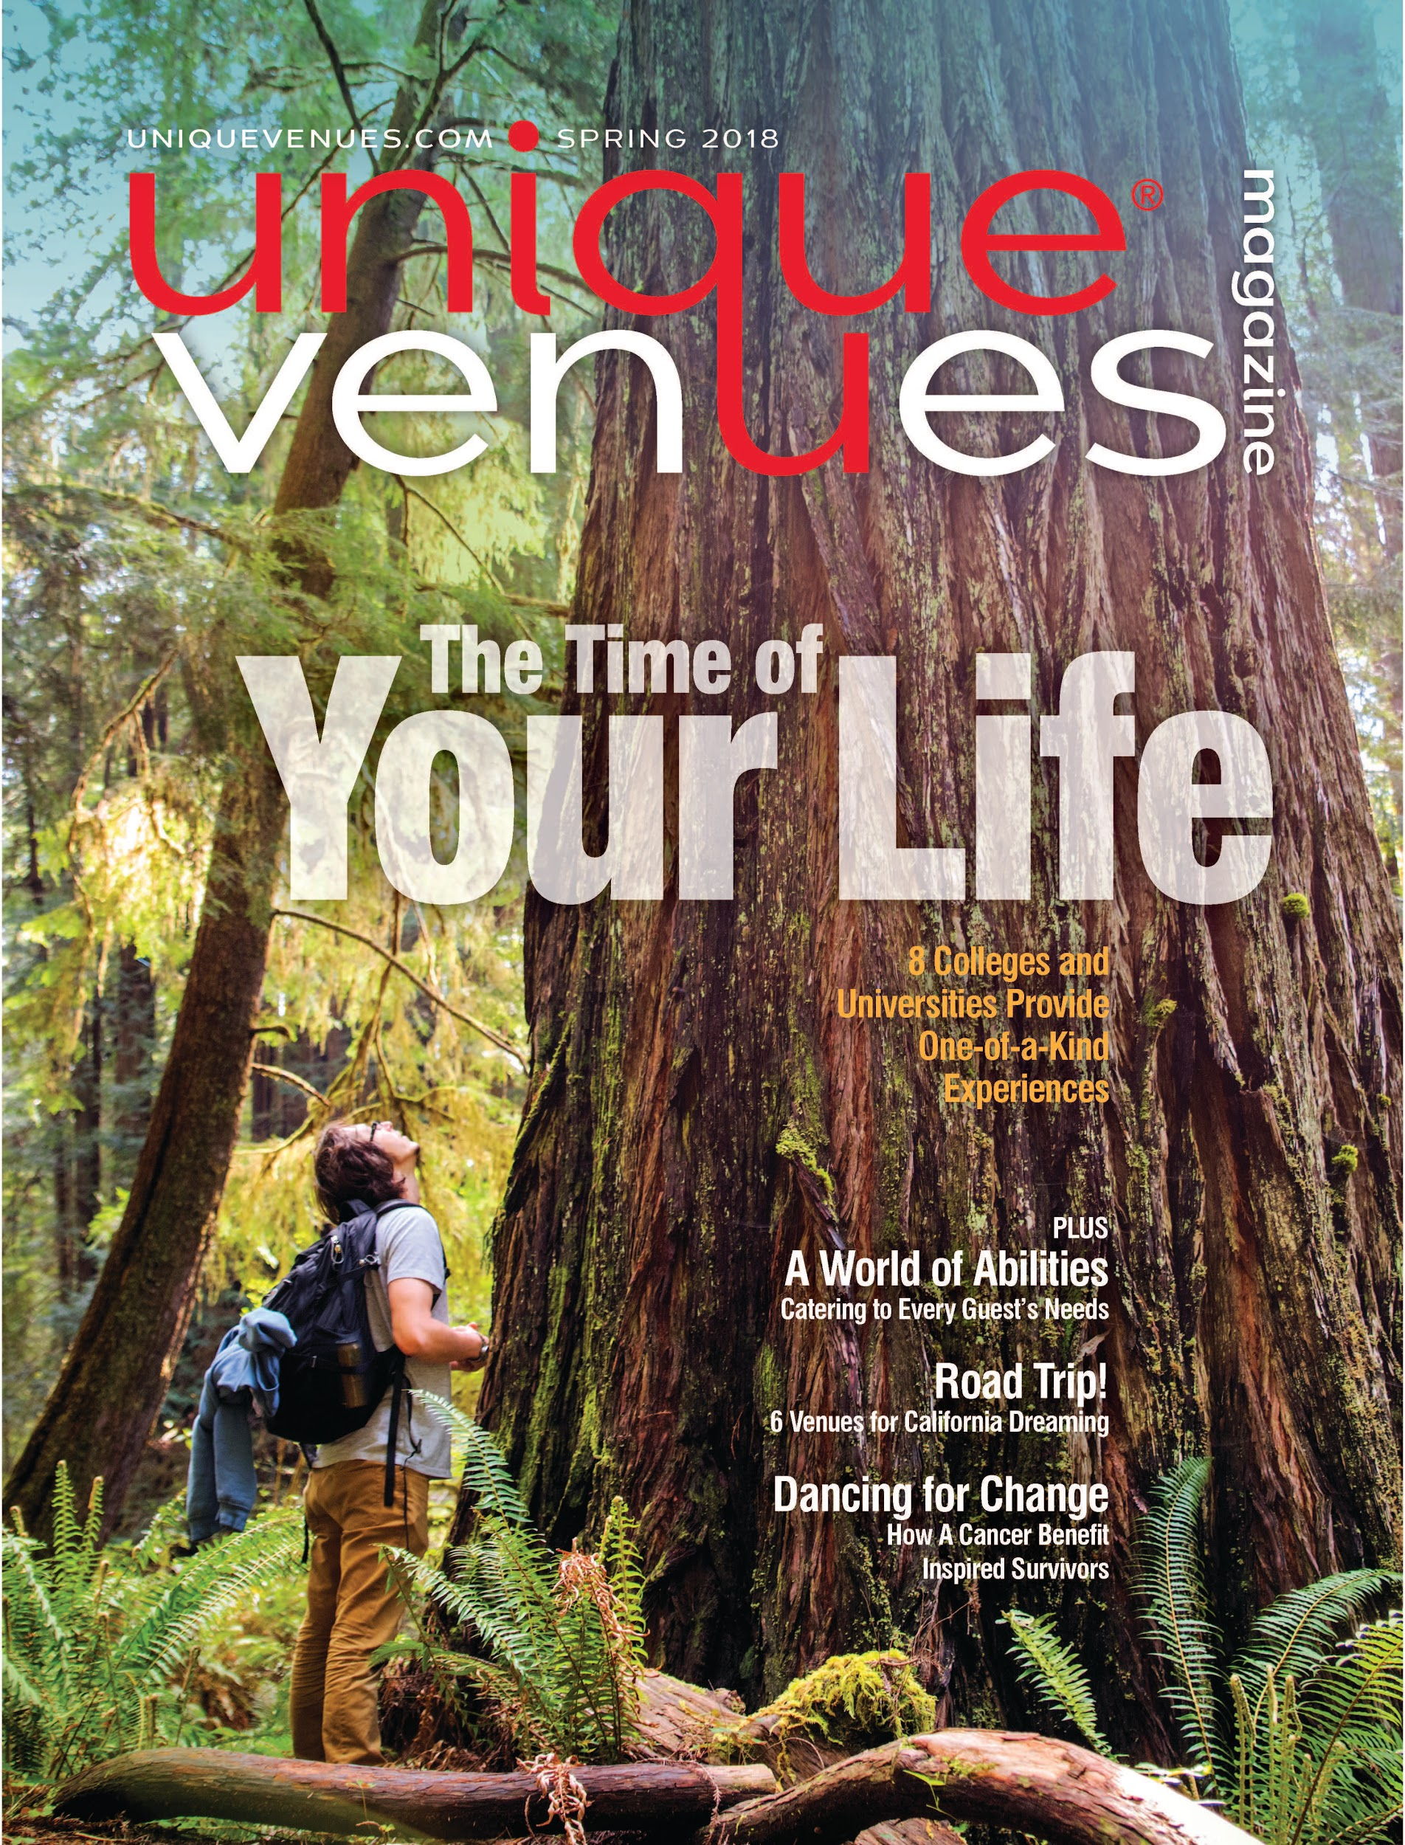

Let’s get an award that we can share in our marketing for HSU!

Please share widely. The more votes the better for us to win.

Thank you!

HSU Conference & Event Services

