Occupancy Survey Procedure

You will receive an email called ‘Space Survey - SRV # ###’ from humboldt@metabim.com (Cal Poly Humboldt FacilitiesLink) requesting your help to review and update occupants in your office spaces.

The information helps your department, division, and campus as a whole plan and manage its space resources effectively. The data is mandatory for certain accounting and workplace compliance requirements.

- Click on the link provided.

- It will take you to the screen below, click on the first building:

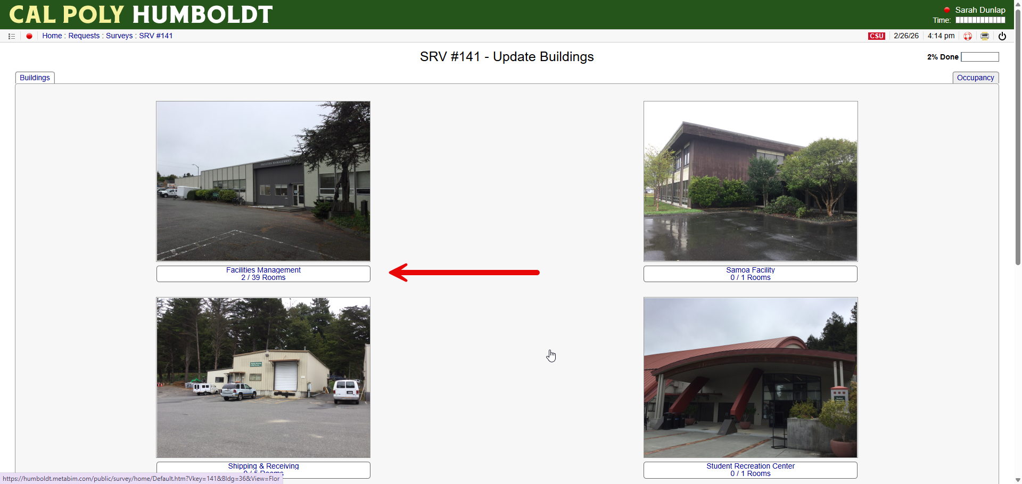

- Click on the floor you would like to confirm occupants:

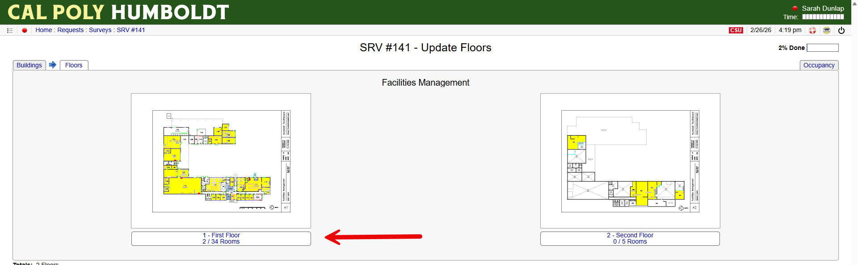

- Click on each room. The blue rooms are completed.

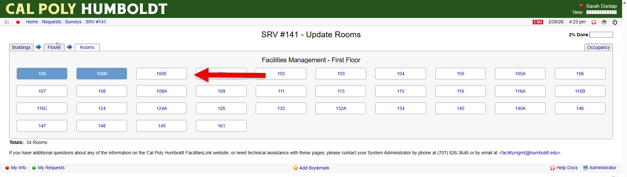

- Either confirm the occupant or enter in the new occupant. Press confirm and go to the next room. If you have comments, please leave them here:

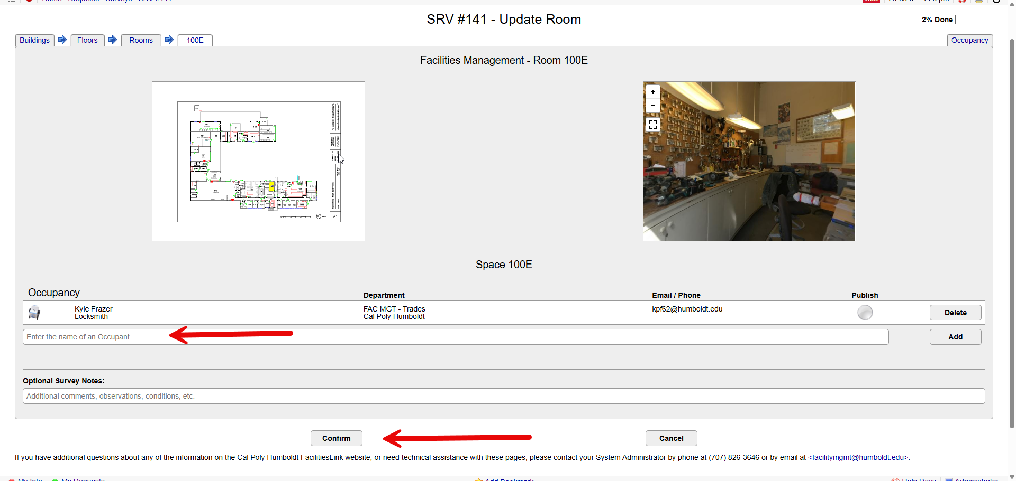

- Continue until all rooms and buildings are confirmed and shaded blue.
- When the survey is complete, you will have an opportunity to enter any additional comments.
- Submit survey for review.

