* 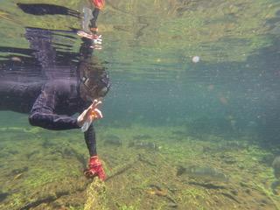

Biology Seminar

Biology Graduate Student Association and

Department of Biological Sciences

**Jose Morin, PhD**

**Assistant Professor**

**Humboldt State University**

**FRIDAY, SEPT. 14 @ 4 PM**

**SCI B 135**

*Dr.* *José Marín Jarrín is an assistant professor in Humboldt State University’s Department of Fisheries Biology. Before joining HSU, Jose worked at the Charles Darwin Foundation (CDF) from May 2016 to July 2018 as a Senior Fisheries Ecologist, with the focus on studying the life history of several commercially important fish species, the impact of El Niño events on artisanal fisheries catch and the role of mangroves for the early life stages of fishes in Galápagos. During that time, Jose was also the interim scientific coordinator for the CDF for nine months, and participated in the sharks, seabirds, seamounts and climate change programs.*

**The underwater Galapagos: The world that Darwin never witnessed**

Biological Sciences Seminar Series venue is wheelchair-accessible. Persons who wish to request disability-related accommodations, including sign-language interpreters, should contact the Department of Biological Sciences, c/o **mtr57@humboldt.edu**. Please request accommodations at least two days prior to the event. Some attendees may be sensitive to various scents from perfumes, shampoos, soaps, etc. Although optional, please consider refraining from wearing scented products to this event.